3. processing
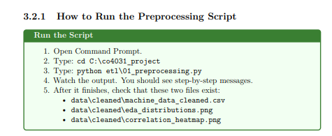
"C:\co4031_project\data\raw\01_exploration.py"
"""
CO4031 - Data Warehouse | BTL Guide
CHAPTER 3. DATA PREPROCESSING
Script: 01_preprocessing.py
"""
import pandas as pd
import numpy as np
import matplotlib.pyplot as plt
import seaborn as sns
import os
import warnings

warnings.filterwarnings('ignore')

# ============================================================
# SECTION 1: Load the Raw Data
# ============================================================

# Define paths
RAW_PATH = r"C:\co4031_project\data\raw\superstore.csv"
CLEANED_PATH = r"C:\co4031_project\data\cleaned\machine_data_cleaned.csv"

print("=" * 60)
print(" STEP 1: Loading Raw Data ")
print("=" * 60)

df = pd.read_csv(RAW_PATH)

print(f"Shape of dataset : {df.shape}")
print(f"Number of rows : {df.shape[0]}")
print(f"Number of cols : {df.shape[1]}")
print()

# Show first 5 rows
print("First 5 rows :")
print(df.head())
print()

# Show column names and types
print("Column data types :")
print(df.dtypes)
print()

# ============================================================
# SECTION 2: Inspect Data Quality
# ============================================================

print("=" * 60)
print(" STEP 2: Data Quality Inspection ")
print("=" * 60)

# Check for missing values
print("Missing values per column :")
missing = df.isnull().sum()
print(missing)
print(f"Total missing values : {missing.sum()}")
print()

# Check for duplicate rows
n_duplicates = df.duplicated().sum()
print(f"Number of duplicate rows : {n_duplicates}")
print()

# Check for outliers (using IQR method)
numeric_cols = [
'Air temperature [K]',
'Process temperature [K]',
'Rotational speed [rpm]',
'Torque [Nm]',
'Tool wear [min]'
]

print("Descriptive statistics for numeric columns :")
print(df[numeric_cols].describe().round(2))
print()

# ============================================================
# SECTION 3: Data Cleaning
# ============================================================

print("=" * 60)
print(" STEP 3: Data Cleaning ")
print("=" * 60)

df_clean = df.copy()

# Step 3a: Remove duplicates (if any)
before = len(df_clean)
df_clean = df_clean.drop_duplicates()
after = len(df_clean)
print(f"Removed {before - after} duplicate rows.")

# Step 3b: Handle missing values
for col in numeric_cols:
null_count = df_clean[col].isnull().sum()
if null_count > 0:
median_val = df_clean[col].median()
df_clean[col].fillna(median_val, inplace=True)
print(f"Filled {null_count} missing values in '{col}' with median = {median_val:.2f}")

print("Missing value handling: Complete.\n")

# Step 3c: Remove physical impossibilities (domain knowledge validation)
original_len = len(df_clean)
df_clean = df_clean[df_clean['Air temperature [K]'] > 0]
df_clean = df_clean[df_clean['Process temperature [K]'] > 0]
df_clean = df_clean[df_clean['Rotational speed [rpm]'] > 0]
df_clean = df_clean[df_clean['Torque [Nm]'] >= 0]
df_clean = df_clean[df_clean['Tool wear [min]'] >= 0]
removed = original_len - len(df_clean)
print(f"Removed {removed} physically impossible records.")

# Step 3d: Remove outliers using IQR for key numeric columns
def remove_iqr_outliers(df, col, factor=3.0):
Q1 = df[col].quantile(0.25)
Q3 = df[col].quantile(0.75)
IQR = Q3 - Q1
lower = Q1 - factor * IQR
upper = Q3 + factor * IQR
before = len(df)
df = df[(df[col] >= lower) & (df[col] <= upper)]
after = len(df)
print(f"'{col}': removed {before - after} outliers (range: {lower:.1f} - {upper:.1f})")
return df

print("Removing extreme outliers (IQR x3):")
for col in ['Rotational speed [rpm]', 'Torque [Nm]']:
df_clean = remove_iqr_outliers(df_clean, col)

print(f"\nRecords after cleaning: {len(df_clean)}\n")

# ============================================================
# SECTION 4: Data Transformation
# ============================================================

print("=" * 60)
print(" STEP 4: Data Transformation ")
print("=" * 60)

# Step 4a: Convert temperatures from Kelvin to Celsius
df_clean['Air_Temp_C'] = df_clean['Air temperature [K]'] - 273.15
df_clean['Process_Temp_C'] = df_clean['Process temperature [K]'] - 273.15
print("Converted temperatures: Kelvin -> Celsius")

# Step 4b: Create derived feature: Temperature Differential
df_clean['Temp_Differential_C'] = df_clean['Process_Temp_C'] - df_clean['Air_Temp_C']
print("Created: Temp_Differential_C (thermal stress indicator)")

# Step 4c: Create Power feature
df_clean['Power_W'] = df_clean['Torque [Nm]'] * (2 * np.pi * df_clean['Rotational speed [rpm]'] / 60)
print("Created: Power_W (mechanical power in Watts)")

# Step 4d: Encode Type column (L=0, M=1, H=2)
type_mapping = {'L': 0, 'M': 1, 'H': 2}
df_clean['Type_Encoded'] = df_clean['Type'].map(type_mapping)
print("Encoded: Type -> Type_Encoded (L=0, M=1, H=2)")

# Step 4e: Create Failure Type Label column for easier reporting
def get_failure_type(row):
if row['TWF'] == 1:
return 'Tool Wear Failure'
elif row['HDF'] == 1:
return 'Heat Dissipation Failure'
elif row['PWF'] == 1:
return 'Power Failure'
elif row['OSF'] == 1:
return 'Overstrain Failure'
elif row['RNF'] == 1:
return 'Random Failure'
else:
return 'No Failure'

df_clean['Failure_Type'] = df_clean.apply(get_failure_type, axis=1)
print("Created: Failure_Type (human-readable failure category)")

# Step 4f: Rename columns to clean names for database use
rename_map = {
'UDI': 'record_id',
'Product ID': 'product_id',
'Type': 'quality_type',
'Air temperature [K]': 'air_temp_k',
'Process temperature [K]': 'process_temp_k',
'Rotational speed [rpm]': 'rotational_speed_rpm',
'Torque [Nm]': 'torque_nm',
'Tool wear [min]': 'tool_wear_min',
'Machine failure': 'machine_failure',
'TWF': 'failure_twf',
'HDF': 'failure_hdf',
'PWF': 'failure_pwf',
'OSF': 'failure_osf',
'RNF': 'failure_rnf'
}
df_clean.rename(columns=rename_map, inplace=True)
print("Renamed all columns to snake_case database-friendly names")

# ============================================================
# SECTION 5: Feature Selection
# ============================================================

print("=" * 60)
print(" STEP 5: Feature Selection ")
print("=" * 60)

# Correlation analysis
feature_cols = [
'air_temp_k', 'process_temp_k', 'rotational_speed_rpm',
'torque_nm', 'tool_wear_min', 'Temp_Differential_C', 'Power_W'
]

print("Correlation with machine_failure:")
correlations = df_clean[feature_cols + ['machine_failure']].corr()['machine_failure']
print(correlations.drop('machine_failure').sort_values(ascending=False))
print("\nAll 7 features will be retained based on domain knowledge.")

# ============================================================
# SECTION 6: Save Cleaned Data
# ============================================================

print("=" * 60)
print(" STEP 6: Saving Cleaned Dataset ")
print("=" * 60)

os.makedirs(os.path.dirname(CLEANED_PATH), exist_ok=True)
df_clean.to_csv(CLEANED_PATH, index=False)

print(f"Cleaned dataset saved to: {CLEANED_PATH}")
print(f"Final shape: {df_clean.shape}\n")
print("Machine failure distribution:")
print(df_clean['machine_failure'].value_counts(normalize=True).round(4) * 100)
print()

# ============================================================
# SECTION 7: Visualize Key Distributions
# ============================================================
print("Creating exploratory visualizations...")

fig, axes = plt.subplots(2, 3, figsize=(15, 10))
fig.suptitle('Feature Distributions by Machine Failure Status', fontsize=14, fontweight='bold')

plot_features = [
('air_temp_k', 'Air Temperature (K)'),
('process_temp_k', 'Process Temperature (K)'),
('rotational_speed_rpm', 'Rotational Speed (RPM)'),
('torque_nm', 'Torque (Nm)'),
('tool_wear_min', 'Tool Wear (min)'),
('Power_W', 'Power (W)')
]

for ax, (col, label) in zip(axes.flatten(), plot_features):
fail = df_clean[df_clean['machine_failure'] == 1][col]
normal = df_clean[df_clean['machine_failure'] == 0][col]
ax.hist(normal, bins=40, alpha=0.6, label='Normal', color='steelblue')
ax.hist(fail, bins=40, alpha=0.7, label='Failure', color='tomato')
ax.set_title(label, fontsize=10)
ax.set_xlabel(label)
ax.set_ylabel('Count')
ax.legend(fontsize=8)

plt.tight_layout()
plot_path = r"C:\co4031_project\data\cleaned\eda_distributions.png"
plt.savefig(plot_path, dpi=150, bbox_inches='tight')
print(f"Saved distribution plot to: {plot_path}")

# Correlation heatmap
fig2, ax2 = plt.subplots(figsize=(10, 8))
corr_matrix = df_clean[feature_cols + ['machine_failure']].corr()
sns.heatmap(corr_matrix, annot=True, fmt='.2f', cmap='coolwarm', center=0, ax=ax2, linewidths=0.5)
ax2.set_title('Feature Correlation Heatmap', fontsize=13, fontweight='bold')

plt.tight_layout()
heatmap_path = r"C:\co4031_project\data\cleaned\correlation_heatmap.png"
plt.savefig(heatmap_path, dpi=150, bbox_inches='tight')
print(f"Saved correlation heatmap to: {heatmap_path}")

print("\n=== PREPROCESSING COMPLETE ===")

PS C:\Users\nguyenhoang88502> & C:/Users/nguyenhoang88502/AppData/Local/Programs/Python/Python314/python.exe c:/co4031_project/data/raw/01_exploration.py
============================================================
STEP 1: Loading Raw Data
============================================================
Shape of dataset : (10000, 14)
Number of rows : 10000
Number of cols : 14

First 5 rows :
UDI Product ID Type Air temperature [K] Process temperature [K] Rotational speed [rpm] Torque [Nm] Tool wear [min] Machine failure TWF HDF PWF OSF RNF
0 1 M14860 M 298.1 308.6 1551 42.8 0 0 0 0 0 0 0
1 2 L47181 L 298.2 308.7 1408 46.3 3 0 0 0 0 0 0
2 3 L47182 L 298.1 308.5 1498 49.4 5 0 0 0 0 0 0
3 4 L47183 L 298.2 308.6 1433 39.5 7 0 0 0 0 0 0
4 5 L47184 L 298.2 308.7 1408 40.0 9 0 0 0 0 0 0

Column data types :
UDI int64
Product ID str
Type str
Air temperature [K] float64
Process temperature [K] float64
Rotational speed [rpm] int64
Torque [Nm] float64
Tool wear [min] int64
Machine failure int64
TWF int64
HDF int64
PWF int64
OSF int64
RNF int64
dtype: object

============================================================
STEP 2: Data Quality Inspection
============================================================
Missing values per column :
UDI 0
Product ID 0
Type 0
Air temperature [K] 0
Process temperature [K] 0
Rotational speed [rpm] 0
Torque [Nm] 0
Tool wear [min] 0
Machine failure 0
TWF 0
HDF 0
PWF 0
OSF 0
RNF 0
dtype: int64
Total missing values : 0

Number of duplicate rows : 0

Descriptive statistics for numeric columns :
Air temperature [K] Process temperature [K] Rotational speed [rpm] Torque [Nm] Tool wear [min]
count 10000.0 10000.00 10000.00 10000.00 10000.00
mean 300.0 310.01 1538.78 39.99 107.95
std 2.0 1.48 179.28 9.97 63.65
min 295.3 305.70 1168.00 3.80 0.00
25% 298.3 308.80 1423.00 33.20 53.00
50% 300.1 310.10 1503.00 40.10 108.00
75% 301.5 311.10 1612.00 46.80 162.00
max 304.5 313.80 2886.00 76.60 253.00

============================================================
STEP 3: Data Cleaning
============================================================
Removed 0 duplicate rows.
Missing value handling: Complete.

Removed 0 physically impossible records.
Removing extreme outliers (IQR x3):
'Rotational speed [rpm]': removed 106 outliers (range: 856.0 - 2179.0)
'Torque [Nm]': removed 0 outliers (range: -6.8 - 87.0)

Records after cleaning: 9894

============================================================
STEP 4: Data Transformation
============================================================
Converted temperatures: Kelvin -> Celsius
Created: Temp_Differential_C (thermal stress indicator)
Created: Power_W (mechanical power in Watts)
Encoded: Type -> Type_Encoded (L=0, M=1, H=2)
Created: Failure_Type (human-readable failure category)
Renamed all columns to snake_case database-friendly names
============================================================
STEP 5: Feature Selection
============================================================
Correlation with machine_failure:
torque_nm 0.257902
Power_W 0.245643
tool_wear_min 0.113177
air_temp_k 0.085221
process_temp_k 0.037582
Temp_Differential_C -0.114509
rotational_speed_rpm -0.172312
Name: machine_failure, dtype: float64

All 7 features will be retained based on domain knowledge.
============================================================
STEP 6: Saving Cleaned Dataset
============================================================
Cleaned dataset saved to: C:\co4031_project\data\cleaned\machine_data_cleaned.csv
Final shape: (9894, 20)

Machine failure distribution:
machine_failure
0 96.89
1 3.11
Name: proportion, dtype: float64

Creating exploratory visualizations...
Saved distribution plot to: C:\co4031_project\data\cleaned\eda_distributions.png
Saved correlation heatmap to: C:\co4031_project\data\cleaned\correlation_heatmap.png

=== PREPROCESSING COMPLETE ===
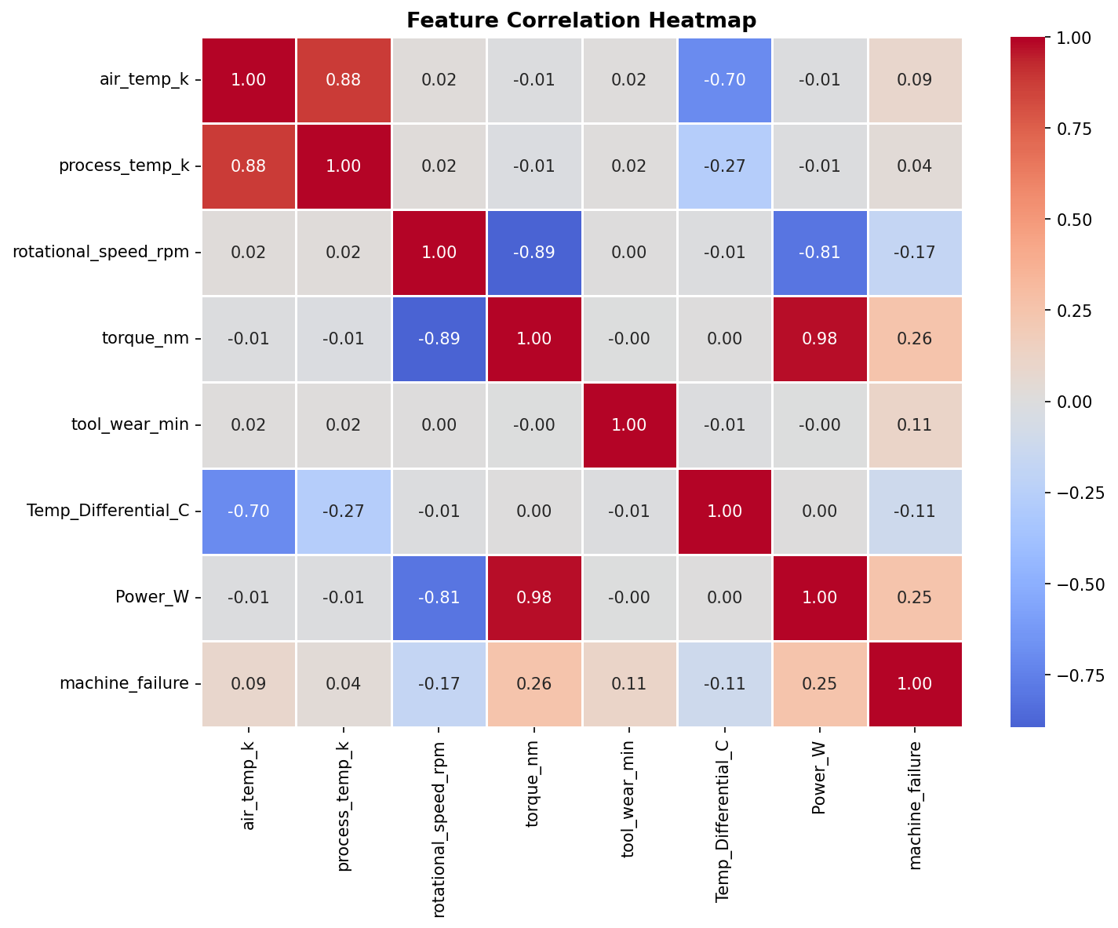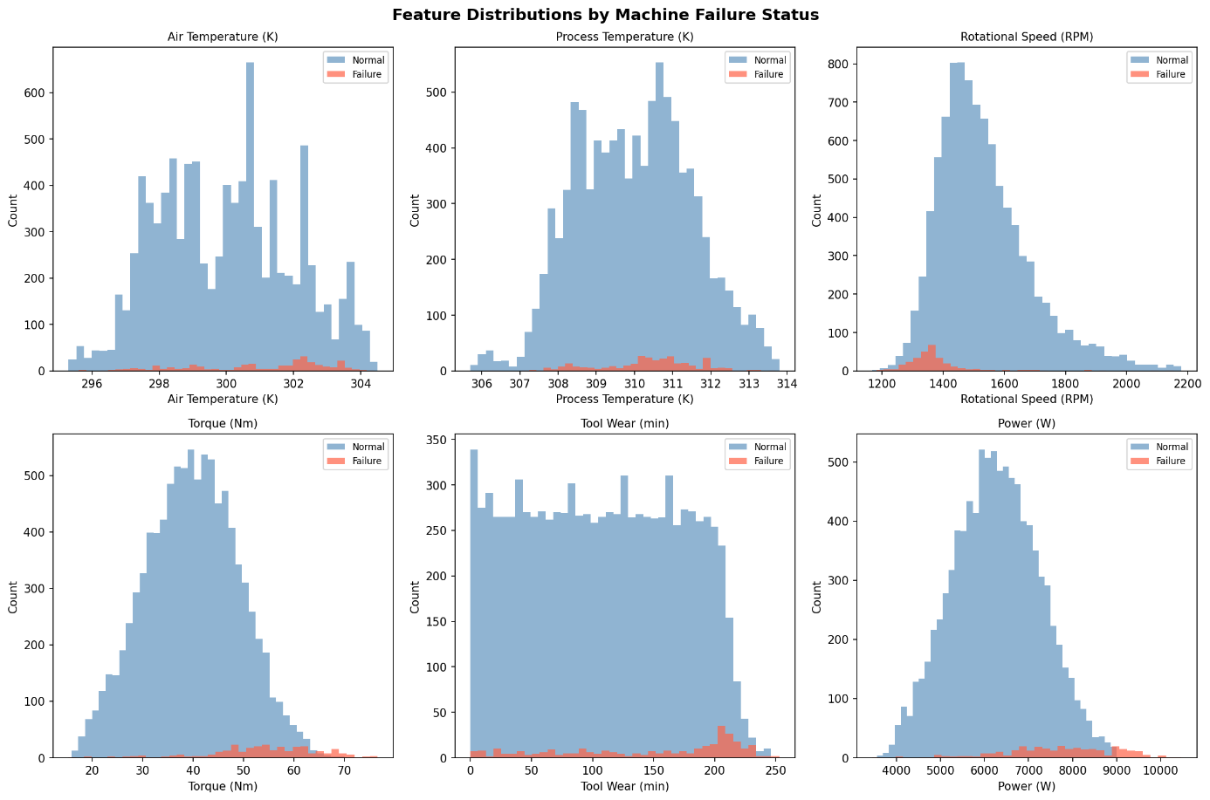

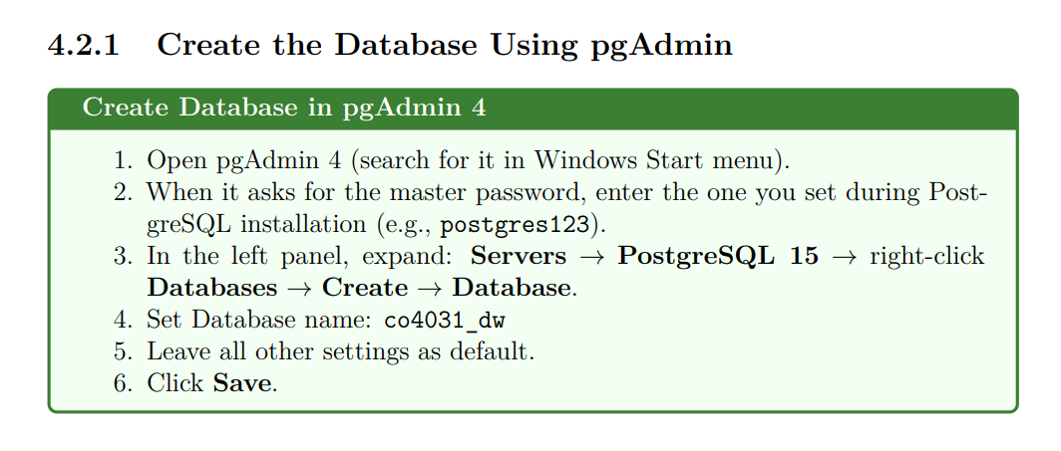
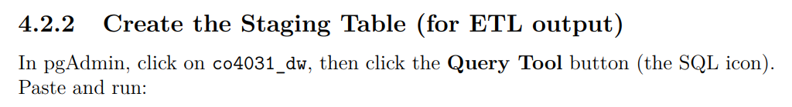
"C:\co4031_project\etl\staging.sql"
-- Create schema for staging area
CREATE SCHEMA IF NOT EXISTS staging;

-- Drop if exists (for clean re-runs during development)
DROP TABLE IF EXISTS staging.machine_data;

-- Create the staging table
CREATE TABLE staging.machine_data (
record_id INTEGER PRIMARY KEY,
product_id VARCHAR(20),
quality_type CHAR(1),
air_temp_k FLOAT,
process_temp_k FLOAT,
rotational_speed_rpm INTEGER,
torque_nm FLOAT,
tool_wear_min INTEGER,
machine_failure SMALLINT,
failure_twf SMALLINT,
failure_hdf SMALLINT,
failure_pwf SMALLINT,
failure_osf SMALLINT,
failure_rnf SMALLINT,
-- Derived / transformed columns
air_temp_c FLOAT,
process_temp_c FLOAT,
temp_differential_c FLOAT,
power_w FLOAT,
type_encoded SMALLINT,
failure_type VARCHAR(50),
load_timestamp TIMESTAMP DEFAULT CURRENT_TIMESTAMP
);

COMMENT ON TABLE staging.machine_data IS
'ETL staging area: cleaned and transformed machine sensor data';

SELECT 'Staging table created successfully' AS status;
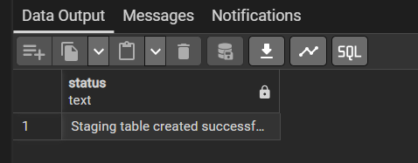
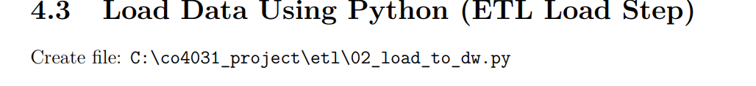
"C:\co4031_project\etl\02 _load_to_dw.py" main step
"""
CO4031 BTL - Step 02: Load Cleaned Data to PostgreSQL
Purpose: Load the transformed CSV into the staging.machine_data table
"""

import pandas as pd
from sqlalchemy import create_engine, text
import warnings
warnings.filterwarnings('ignore')

# ============================================================
# CONNECTION CONFIGURATION
# ============================================================
# Change these if your PostgreSQL settings are different:
DB_USER = "postgres"
DB_PASSWORD = "885028" # your PostgreSQL password
DB_HOST = "localhost"
DB_PORT = "5432"
DB_NAME = "co4031_dw"

CLEANED_PATH = r"C:\co4031_project\data\cleaned\machine_data_cleaned.csv"

# Build connection string
conn_str = f"postgresql+psycopg2://{DB_USER}:{DB_PASSWORD}@{DB_HOST}:{DB_PORT}/{DB_NAME}"

print("Connecting to PostgreSQL...")
engine = create_engine(conn_str)

# Test connection
with engine.connect() as conn:
result = conn.execute(text("SELECT version()"))
print(f"Connected! PostgreSQL version: {result.fetchone()[0][:30]}...")

# ============================================================
# LOAD DATA
# ============================================================

print("\nLoading cleaned CSV file...")
df = pd.read_csv(CLEANED_PATH)
print(f"Loaded {len(df)} rows, {len(df.columns)} columns.")

# Select and rename columns to match database table exactly
db_columns = [
'record_id', 'product_id', 'quality_type',
'air_temp_k', 'process_temp_k', 'rotational_speed_rpm',
'torque_nm', 'tool_wear_min', 'machine_failure',
'failure_twf', 'failure_hdf', 'failure_pwf',
'failure_osf', 'failure_rnf',
'Air_Temp_C', 'Process_Temp_C',
'Temp_Differential_C', 'Power_W',
'Type_Encoded', 'Failure_Type'
]

# Rename derived columns to lowercase for DB consistency
df = df.rename(columns={
'Air_Temp_C': 'air_temp_c',
'Process_Temp_C': 'process_temp_c',
'Temp_Differential_C': 'temp_differential_c',
'Power_W': 'power_w',
'Type_Encoded': 'type_encoded',
'Failure_Type': 'failure_type'
})

print("Loading data to staging.machine_data table...")

# Load using pandas to_sql (much faster than row-by-row INSERT)
df.to_sql(
name='machine_data',
schema='staging',
con=engine,
if_exists='replace', # 'replace' drops and recreates; use 'append' later
index=False,
chunksize=1000, # process 1000 rows at a time
method='multi' # batch inserts (faster)
)

# Verify the load
with engine.connect() as conn:
count = conn.execute(
text("SELECT COUNT(*) FROM staging.machine_data")
).fetchone()[0]
print(f"\nVerification: {count} rows loaded to staging.machine_data")

# Show sample
sample = conn.execute(
text("SELECT record_id, quality_type, machine_failure, failure_type "
"FROM staging.machine_data LIMIT 5")
)
print("\nSample rows:")
for row in sample:
print(f"ID={row[0]}, Type={row[1]}, Failure={row[2]}, Kind='{row[3]}'")

print("\n=== ETL LOAD COMPLETE ===")

Pentaho etl optional

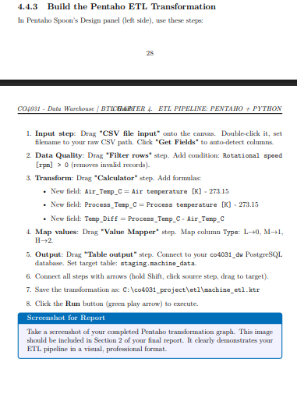
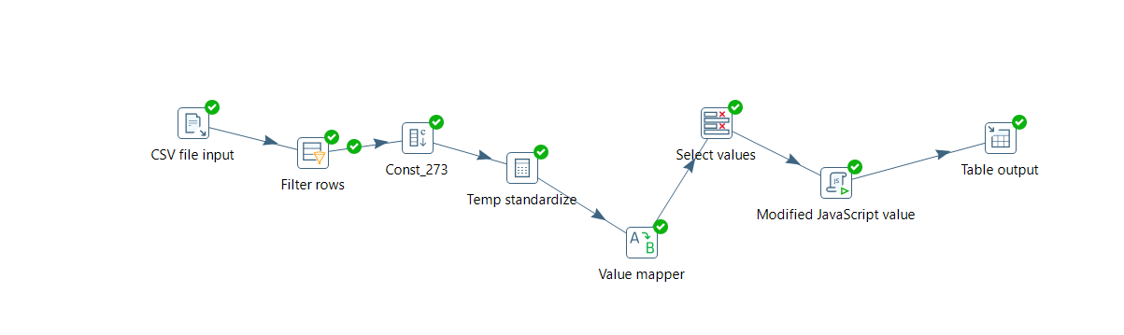
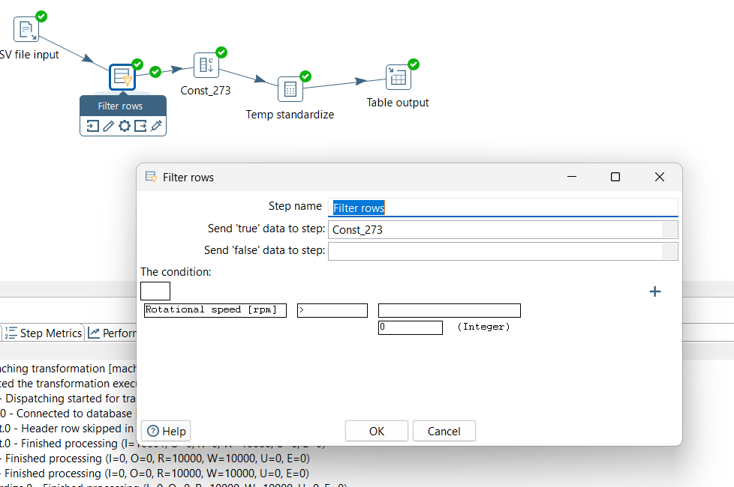

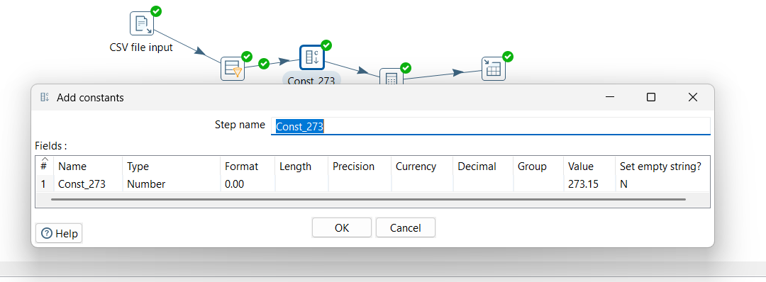
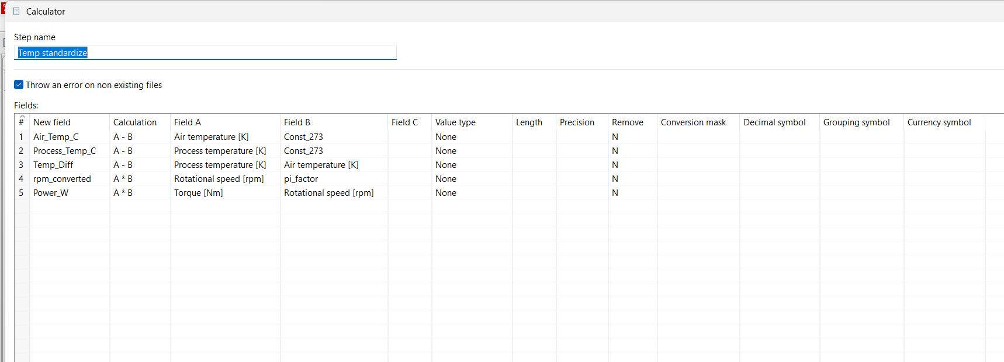
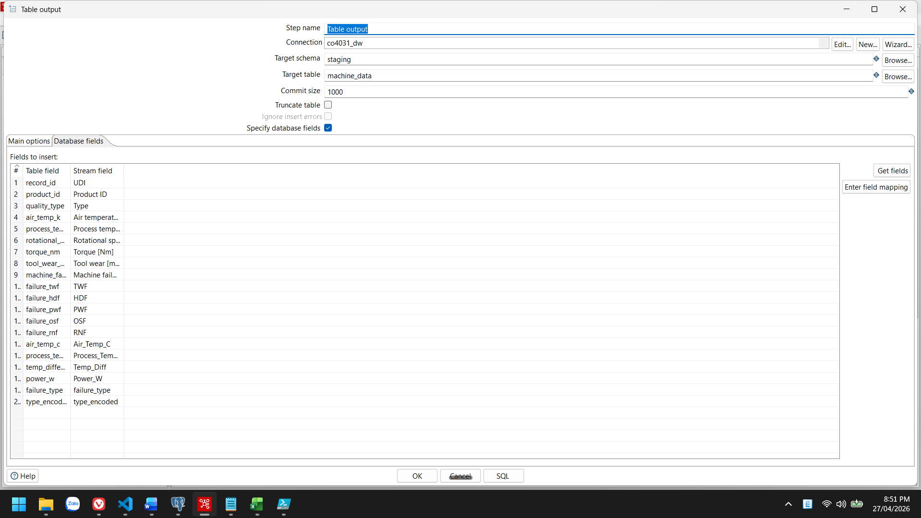
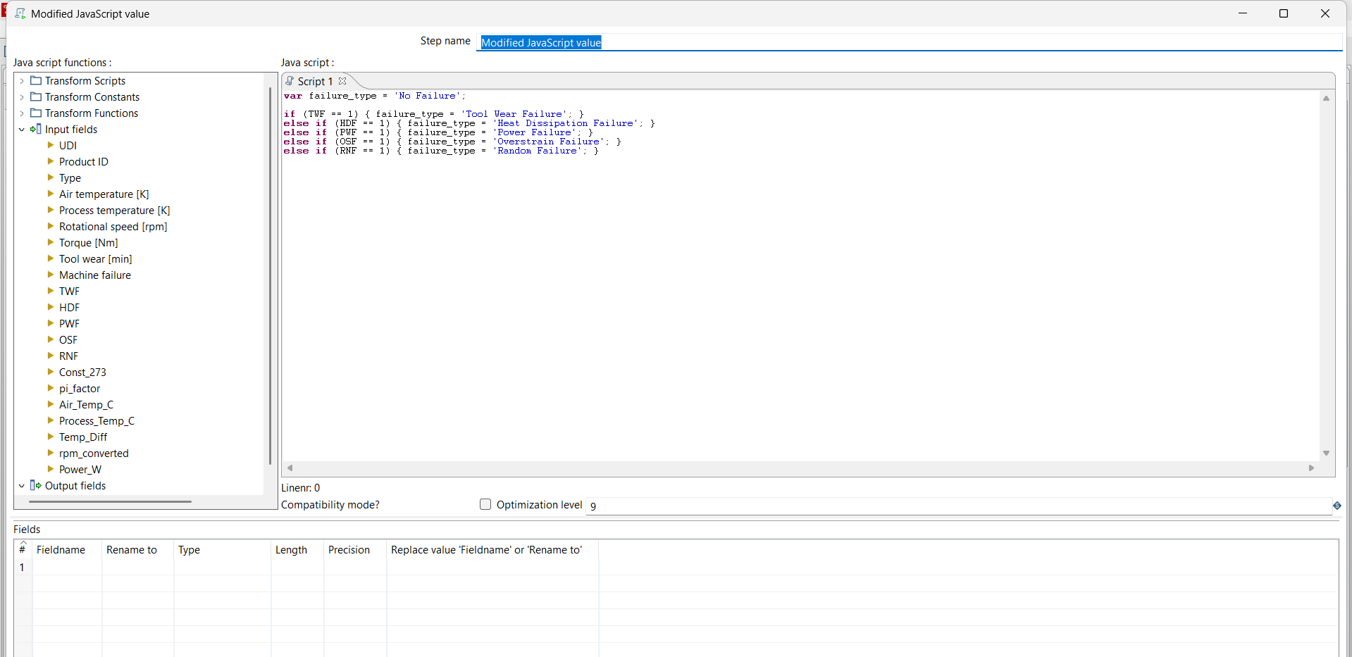

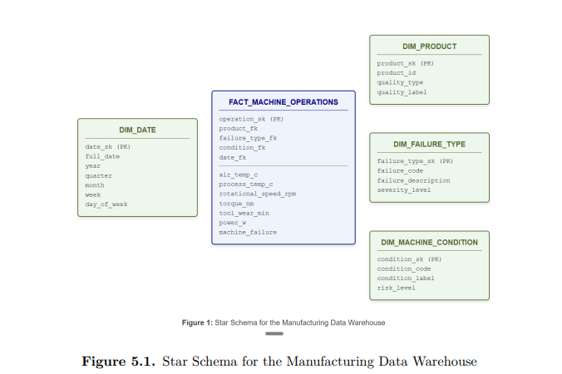
"C:\co4031_project\dw\01_create_star_schema.sql"
-- ============================================================
-- CO4031 BTL - Data Warehouse Star Schema
-- Database : co4031_dw
-- ============================================================

-- Create DW schema
CREATE SCHEMA IF NOT EXISTS dw;

-- ============================================================
-- DIMENSION TABLE 1: DIM_DATE
-- ============================================================
DROP TABLE IF EXISTS dw.dim_date CASCADE;

CREATE TABLE dw.dim_date (
date_sk SERIAL PRIMARY KEY,
full_date DATE NOT NULL UNIQUE,
year SMALLINT NOT NULL,
quarter SMALLINT NOT NULL, -- 1, 2, 3, 4
month SMALLINT NOT NULL,
month_name VARCHAR(15) NOT NULL,
week SMALLINT NOT NULL, -- ISO week number
day_of_month SMALLINT NOT NULL,
day_of_week SMALLINT NOT NULL, -- 1=Mon, 7=Sun
day_name VARCHAR(15) NOT NULL,
is_weekend BOOLEAN NOT NULL
);

COMMENT ON TABLE dw.dim_date IS 'Date dimension table for temporal analysis';

-- Populate dim_date for 2023 (simulated data period)
INSERT INTO dw.dim_date
(full_date, year, quarter, month, month_name, week,
day_of_month, day_of_week, day_name, is_weekend)
SELECT
d::DATE AS full_date,
EXTRACT(YEAR FROM d)::SMALLINT AS year,
EXTRACT(QUARTER FROM d)::SMALLINT AS quarter,
EXTRACT(MONTH FROM d)::SMALLINT AS month,
TO_CHAR(d, 'Month') AS month_name,
EXTRACT(WEEK FROM d)::SMALLINT AS week,
EXTRACT(DAY FROM d)::SMALLINT AS day_of_month,
EXTRACT(ISODOW FROM d)::SMALLINT AS day_of_week,
TO_CHAR(d, 'Day') AS day_name,
EXTRACT(ISODOW FROM d) IN (6, 7) AS is_weekend
FROM generate_series('2023-01-01'::DATE, '2023-12-31'::DATE, '1 day'::INTERVAL) AS s(d);

-- ============================================================
-- DIMENSION TABLE 2: DIM_PRODUCT
-- ============================================================
DROP TABLE IF EXISTS dw.dim_product CASCADE;

CREATE TABLE dw.dim_product (
product_sk SERIAL PRIMARY KEY,
product_id VARCHAR(20) NOT NULL,
quality_type CHAR(1) NOT NULL, -- L, M, H
quality_label VARCHAR(30) NOT NULL,
quality_tier SMALLINT NOT NULL -- 1=Low, 2=Medium, 3=High
);

COMMENT ON TABLE dw.dim_product IS 'Product dimension: quality grades and product codes';

-- ============================================================
-- DIMENSION TABLE 3: DIM_FAILURE_TYPE
-- ============================================================
DROP TABLE IF EXISTS dw.dim_failure_type CASCADE;

CREATE TABLE dw.dim_failure_type (
failure_type_sk SERIAL PRIMARY KEY,
failure_code VARCHAR(5) NOT NULL UNIQUE,
failure_name VARCHAR(60) NOT NULL,
failure_category VARCHAR(30) NOT NULL,
severity_level SMALLINT NOT NULL, -- 1=Low, 2=Medium, 3=High
description TEXT
);

COMMENT ON TABLE dw.dim_failure_type IS 'Failure type dimension: codes, names, and severity';

-- Insert all failure types including "No Failure"
INSERT INTO dw.dim_failure_type
(failure_code, failure_name, failure_category, severity_level, description)
VALUES
('NF', 'No Failure', 'Normal', 1, 'Machine operated within normal parameters. No failure detected.'),
('TWF', 'Tool Wear Failure', 'Mechanical', 2, 'Failure caused by excessive tool wear beyond service limit.'),
('HDF', 'Heat Dissipation Failure', 'Thermal', 3, 'Failure due to inadequate heat dissipation causing overheating.'),
('PWF', 'Power Failure', 'Electrical', 3, 'Failure caused by power supply operating outside rated parameters.'),
('OSF', 'Overstrain Failure', 'Mechanical', 3, 'Failure caused by mechanical overstrain exceeding torque limits.'),
('RNF', 'Random Failure', 'Unknown', 2, 'Failure with no identifiable root cause. Requires investigation.');

-- ============================================================
-- DIMENSION TABLE 4: DIM_MACHINE_CONDITION
-- ============================================================
DROP TABLE IF EXISTS dw.dim_machine_condition CASCADE;

CREATE TABLE dw.dim_machine_condition (
condition_sk SERIAL PRIMARY KEY,
condition_code VARCHAR(10) NOT NULL UNIQUE,
condition_label VARCHAR(30) NOT NULL,
risk_level SMALLINT NOT NULL, -- 1=Low, 2=Med, 3=High, 4=Critical
risk_label VARCHAR(20) NOT NULL,
action_required TEXT NOT NULL
);

COMMENT ON TABLE dw.dim_machine_condition IS 'Machine health condition dimension for maintenance decisions';

INSERT INTO dw.dim_machine_condition
(condition_code, condition_label, risk_level, risk_label, action_required)
VALUES
('NEW_TOOL', 'New Tool (0-100 min)', 1, 'Low', 'Continue normal operation. Schedule next inspection.'),
('MID_TOOL', 'Mid-Life Tool (100-200 min)', 2, 'Medium', 'Monitor closely. Plan tool replacement within 3 days.'),
('OLD_TOOL', 'Aging Tool (200-240 min)', 3, 'High', 'Prioritize tool replacement at next opportunity.'),
('WORN_TOOL', 'Worn Tool (>240 min)', 4, 'Critical', 'Stop machine and replace tool immediately.');

-- ============================================================
-- FACT TABLE : FACT_MACHINE_OPERATIONS
-- ============================================================
DROP TABLE IF EXISTS dw.fact_machine_operations CASCADE;

CREATE TABLE dw.fact_machine_operations (
operation_sk BIGSERIAL PRIMARY KEY,
-- Foreign keys to dimensions
product_fk INTEGER NOT NULL REFERENCES dw.dim_product(product_sk),
failure_type_fk INTEGER NOT NULL REFERENCES dw.dim_failure_type(failure_type_sk),
condition_fk INTEGER NOT NULL REFERENCES dw.dim_machine_condition(condition_sk),
date_fk INTEGER NOT NULL REFERENCES dw.dim_date(date_sk),
-- Source tracking
source_record_id INTEGER NOT NULL, -- UDI from original CSV
-- Measurements (facts / metrics)
air_temp_c FLOAT NOT NULL,
process_temp_c FLOAT NOT NULL,
temp_differential_c FLOAT NOT NULL,
rotational_speed_rpm INTEGER NOT NULL,
torque_nm FLOAT NOT NULL,
tool_wear_min INTEGER NOT NULL,
power_w FLOAT NOT NULL,
-- Outcome flags
machine_failure SMALLINT NOT NULL,
failure_twf SMALLINT NOT NULL,
failure_hdf SMALLINT NOT NULL,
failure_pwf SMALLINT NOT NULL,
failure_osf SMALLINT NOT NULL,
failure_rnf SMALLINT NOT NULL
);

COMMENT ON TABLE dw.fact_machine_operations IS 'Central fact table: one row per manufacturing operation / cycle';

-- Create indexes for query performance
CREATE INDEX idx_fact_product ON dw.fact_machine_operations(product_fk);
CREATE INDEX idx_fact_failure ON dw.fact_machine_operations(failure_type_fk);
CREATE INDEX idx_fact_date ON dw.fact_machine_operations(date_fk);
CREATE INDEX idx_fact_fail_flag ON dw.fact_machine_operations(machine_failure);
"C:\co4031_project\dw\02_populate_star.py"
"""
CO4031 BTL - Step: Populate Star Schema from Staging
Purpose: Reads from staging.machine_data, loads into dw.* tables
"""

import pandas as pd
from sqlalchemy import create_engine, text
import numpy as np
from datetime import date, timedelta
import random
import warnings

warnings.filterwarnings('ignore')

# ============================================================
# CONNECTION CONFIGURATION
# ============================================================
DB_USER = "postgres"
DB_PASSWORD = "885028" # Update this to your actual password!
DB_HOST = "localhost"
DB_PORT = "5432"
DB_NAME = "co4031_dw"

conn_str = f"postgresql+psycopg2://{DB_USER}:{DB_PASSWORD}@{DB_HOST}:{DB_PORT}/{DB_NAME}"
engine = create_engine(conn_str)

print("Loading staging data...")
df = pd.read_sql("SELECT * FROM staging.machine_data", engine)
print(f"Loaded {len(df)} rows from staging.")

# ============================================================
# POPULATE DIM_PRODUCT
# ============================================================
print("\nPopulating dim_product ...")

quality_label_map = {
'L': 'Low Quality',
'M': 'Medium Quality',
'H': 'High Quality'
}
quality_tier_map = {'L': 1, 'M': 2, 'H': 3}

products = df[['product_id', 'quality_type']].drop_duplicates()
products['quality_label'] = products['quality_type'].map(quality_label_map)
products['quality_tier'] = products['quality_type'].map(quality_tier_map)

with engine.connect() as conn:
conn.execute(text("DELETE FROM dw.dim_product"))
conn.commit()

products.to_sql('dim_product', schema='dw', con=engine, if_exists='append', index=False)
print(f"Inserted {len(products)} product records.")

# Fetch back product SK mapping
dim_prod_df = pd.read_sql("SELECT product_sk, product_id FROM dw.dim_product", engine)
prod_map = dict(zip(dim_prod_df['product_id'], dim_prod_df['product_sk']))

# ============================================================
# POPULATE DIM_FAILURE_TYPE (already populated via SQL)
# ============================================================
dim_fail_df = pd.read_sql("SELECT failure_type_sk, failure_code FROM dw.dim_failure_type", engine)
fail_code_map = dict(zip(dim_fail_df['failure_code'], dim_fail_df['failure_type_sk']))

def get_failure_code(row):
if row['failure_twf'] == 1: return 'TWF'
if row['failure_hdf'] == 1: return 'HDF'
if row['failure_pwf'] == 1: return 'PWF'
if row['failure_osf'] == 1: return 'OSF'
if row['failure_rnf'] == 1: return 'RNF'
return 'NF'

df['failure_code'] = df.apply(get_failure_code, axis=1)
df['failure_type_fk'] = df['failure_code'].map(fail_code_map)

# ============================================================
# POPULATE DIM_MACHINE_CONDITION
# ============================================================
dim_cond_df = pd.read_sql("SELECT condition_sk, condition_code FROM dw.dim_machine_condition", engine)
cond_map = dict(zip(dim_cond_df['condition_code'], dim_cond_df['condition_sk']))

def get_condition_code(wear_min):
if wear_min <= 100: return 'NEW_TOOL'
if wear_min <= 200: return 'MID_TOOL'
if wear_min <= 240: return 'OLD_TOOL'
return 'WORN_TOOL'

df['condition_code'] = df['tool_wear_min'].apply(get_condition_code)
df['condition_fk'] = df['condition_code'].map(cond_map)

# ============================================================
# SIMULATE DATES (since dataset has no timestamps)
# ============================================================
# We assign records to business days in 2023, simulating 10,000 operations
random.seed(42)
start_date = date(2023, 1, 2)
all_biz_days = []
d = start_date
while len(all_biz_days) < 400: # Ensure enough days
if d.weekday() < 5: # Monday-Friday
all_biz_days.append(d)
d += timedelta(days=1)

assigned_dates = [random.choice(all_biz_days) for _ in range(len(df))]
df['simulated_date'] = assigned_dates

# Fetch date dimension SK map
dim_date_df = pd.read_sql("SELECT date_sk, full_date FROM dw.dim_date", engine)
dim_date_df['full_date'] = pd.to_datetime(dim_date_df['full_date']).dt.date
date_map = dict(zip(dim_date_df['full_date'], dim_date_df['date_sk']))
df['date_fk'] = df['simulated_date'].map(date_map)

# ============================================================
# POPULATE FACT TABLE
# ============================================================
print("\nPopulating fact_machine_operations ...")

df['product_fk'] = df['product_id'].map(prod_map)

fact_cols = [
'product_fk', 'failure_type_fk', 'condition_fk', 'date_fk',
'record_id', # this will become source_record_id
'air_temp_c', 'process_temp_c', 'temp_differential_c',
'rotational_speed_rpm', 'torque_nm', 'tool_wear_min', 'power_w',
'machine_failure', 'failure_twf', 'failure_hdf', 'failure_pwf',
'failure_osf', 'failure_rnf'
]

# Create fact dataframe and rename the source tracking ID
fact_df = df[fact_cols].copy()
fact_df = fact_df.rename(columns={'record_id': 'source_record_id'})

# Drop nulls in FKs (safety check)
before = len(fact_df)
fact_df = fact_df.dropna(subset=['product_fk', 'failure_type_fk', 'condition_fk', 'date_fk'])
dropped = before - len(fact_df)
if dropped > 0:
print(f"Warning: dropped {dropped} rows with null FK values")

# Load to fact table
with engine.connect() as conn:
conn.execute(text("DELETE FROM dw.fact_machine_operations"))
conn.commit()

fact_df.to_sql('fact_machine_operations', schema='dw', con=engine, if_exists='append', index=False, chunksize=500, method='multi')

# Verify
with engine.connect() as conn:
cnt = conn.execute(text("SELECT COUNT(*) FROM dw.fact_machine_operations")).fetchone()[0]
print(f"Inserted {cnt} rows into fact_machine_operations.")

fail_cnt = conn.execute(text("SELECT COUNT(*) FROM dw.fact_machine_operations WHERE machine_failure = 1")).fetchone()[0]
print(f"Of which {fail_cnt} are failure records.")

print("\n=== STAR SCHEMA POPULATION COMPLETE ===")

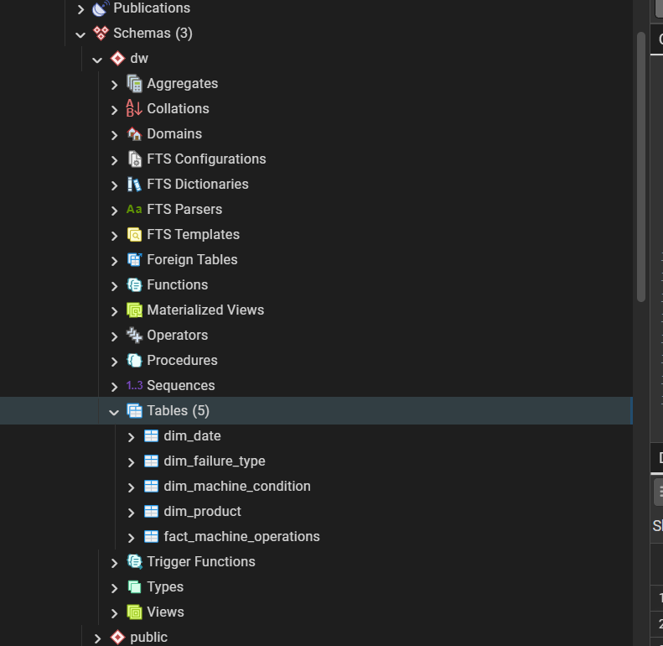
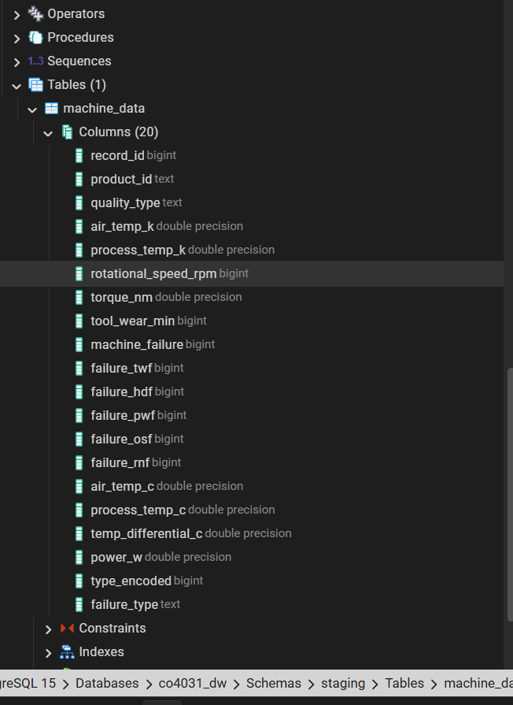

OLAP
-- OLAP Query 2: Monthly Failure Trend
SELECT
d.year AS "Year",
d.month AS "Month",
d.month_name AS "Month Name",
COUNT(*) AS "Operations",
SUM(f.machine_failure) AS "Failures",
ROUND(100.0 * SUM(f.machine_failure) / COUNT(*), 2) AS "Failure Rate (%)"
FROM dw.fact_machine_operations f
JOIN dw.dim_date d ON f.date_fk = d.date_sk
GROUP BY d.year, d.month, d.month_name
ORDER BY d.year, d.month;
"C:\co4031_project\dw\OLAP Monthly Failure Trend.csv"
"Year" "Month" "Month Name" "Operations" "Failures" "Failure Rate (%)"
2023 1 "January " 490 18 3.67
2023 2 "February " 502 17 3.39
2023 3 "March " 585 23 3.93
2023 4 "April " 516 17 3.29
2023 5 "May " 533 23 4.32
2023 6 "June " 526 19 3.61
2023 7 "July " 501 23 4.59
2023 8 "August " 590 20 3.39
2023 9 "September" 515 21 4.08
2023 10 "October " 550 18 3.27
2023 11 "November " 552 17 3.08
2023 12 "December " 530 24 4.53

